Scaling out DB servers

Basic concept
It is to scale out the database, insert/update in multiple servers. This idea has be suggested by Phuong to Joe/Thien around one year ago, and it’s then discussed with Bill again recently in his trip to HCM.
- Scaling-up (change to other DBMS/upgrade to higher version of SQL Server/Upgrade hardware) leads to other near-future limit.
- Scaling-out is more helpful in terms of future expansion and utilizes current knowledge of SQL Server. Once this can be done, to support more user/transactions is just to plug-in new server(s) without changing structure, schema.
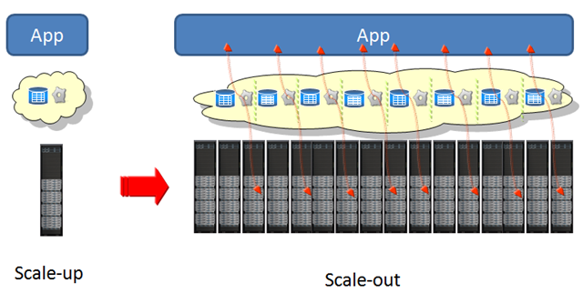

Purposes
- Resolve the overhead of too many transactions on one big server.
- Resolve the overhead of updating a super setting or some amount of customers.
- Can support bigger volume of transactions inserted/updated per second.
- Can extend later with less worrying about bottleneck.
- Resolve the requirement of continuous transid for IPO/TST certification
- If required, it’s possible to put the TransactionDBs at different locations to meet IOM’s requirement. And each TransactionDB machine can be owned by the licensee.

Risks
- Larger numbers of servers means increased management complexity, as well as a more complex programming model.
- Must find a proper way to handle the case in which “hometotal, awaytotal,..” of odds table is replicated from Transaction DB to Products DB.
  - We might replicate bettrans table to DB02. Then might use trigger on bettrans to update “hometotal, awaytotal,…” directly on odds table.
Suggested structure is as below:

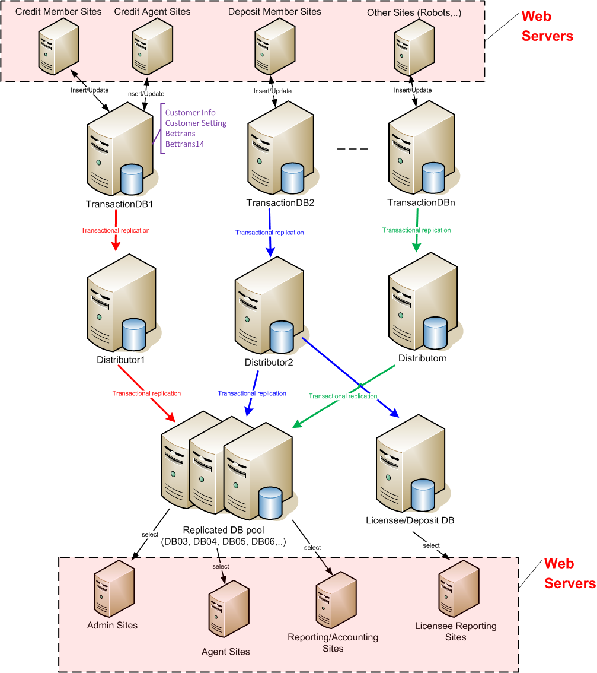

Rough ideas for implementation
- Focus on huge data tables of customer/custsetting/bettrans.
- Suggested to scatter data by credit sites versus deposit sites initially. Later on we may consider scaling out by group of super agents.
- It’s best to separate different distributors for different publishers. However, distributors can still be shared.
- Product DB is not included in this structure, but it must be in consideration of implementation. And this is somehow troublesome since in the structure, “hometotal, awaytotal,..” of odds table is replicated from Transaction DB to Products DB.
- The identity (transid, custid) in bettrans and customer table in scattered Transaction DBs to be seeded with different ranges of values.

